Name: YinHui Wu

Sun is placed at the center of the universe, then I found three planets that revolve around it such as Mars, Uranus, Earth. With different masses is being sent with different velocities the Sun and Simulate their movement.

Pure equations:

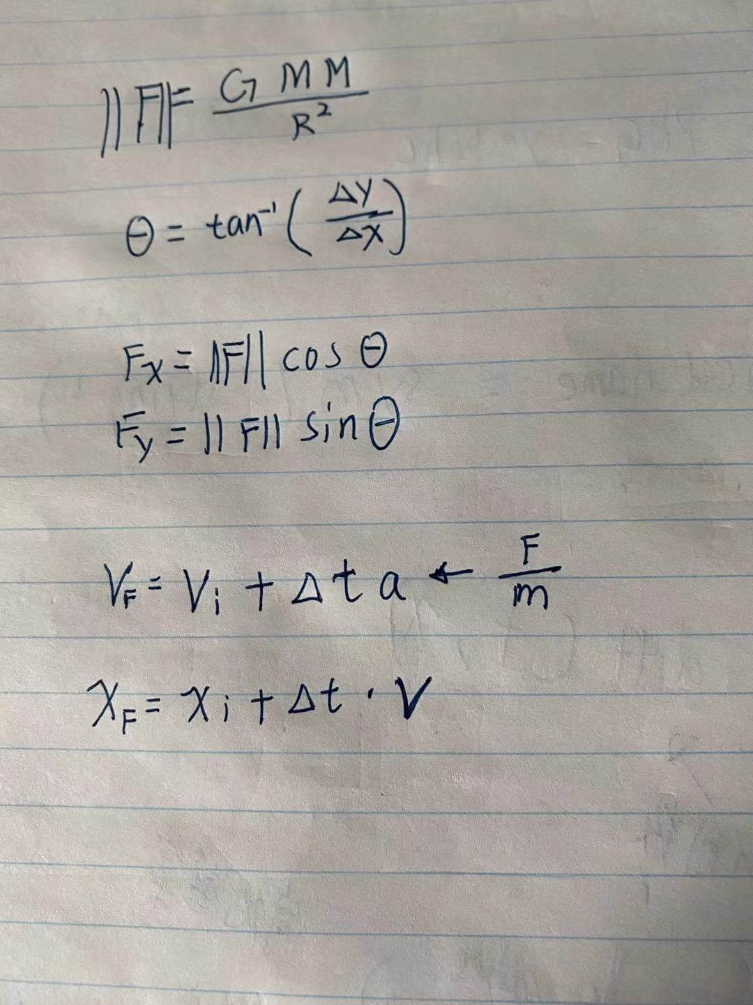

**Proposed methodology to solve the problem：**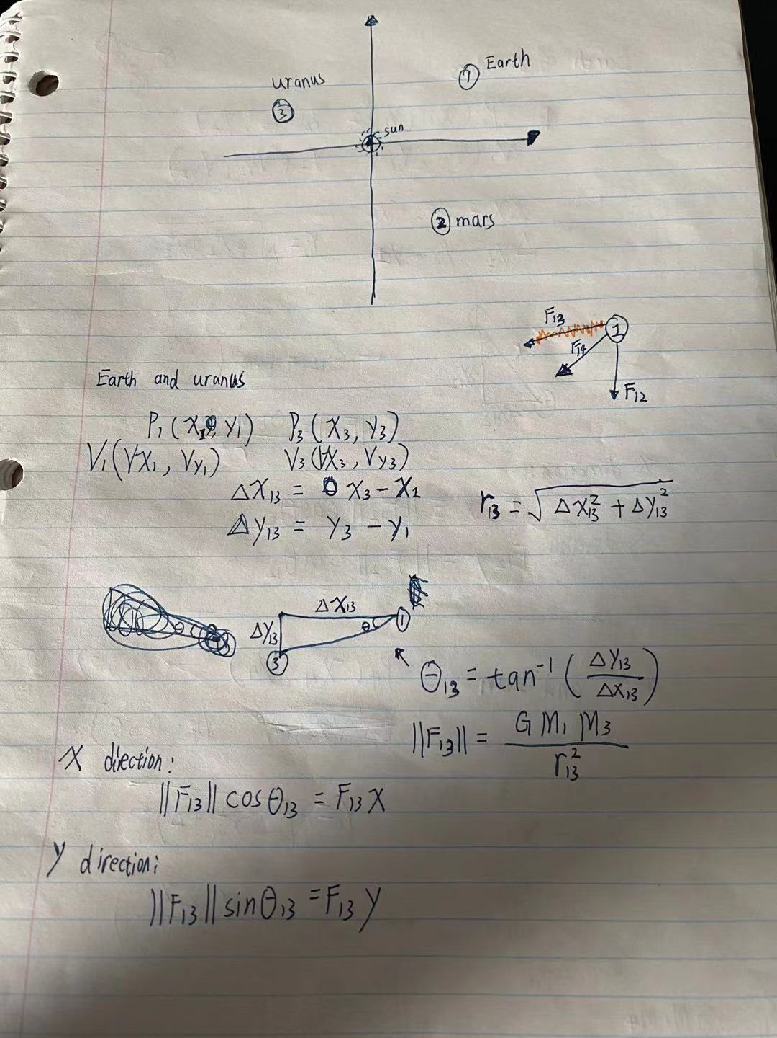

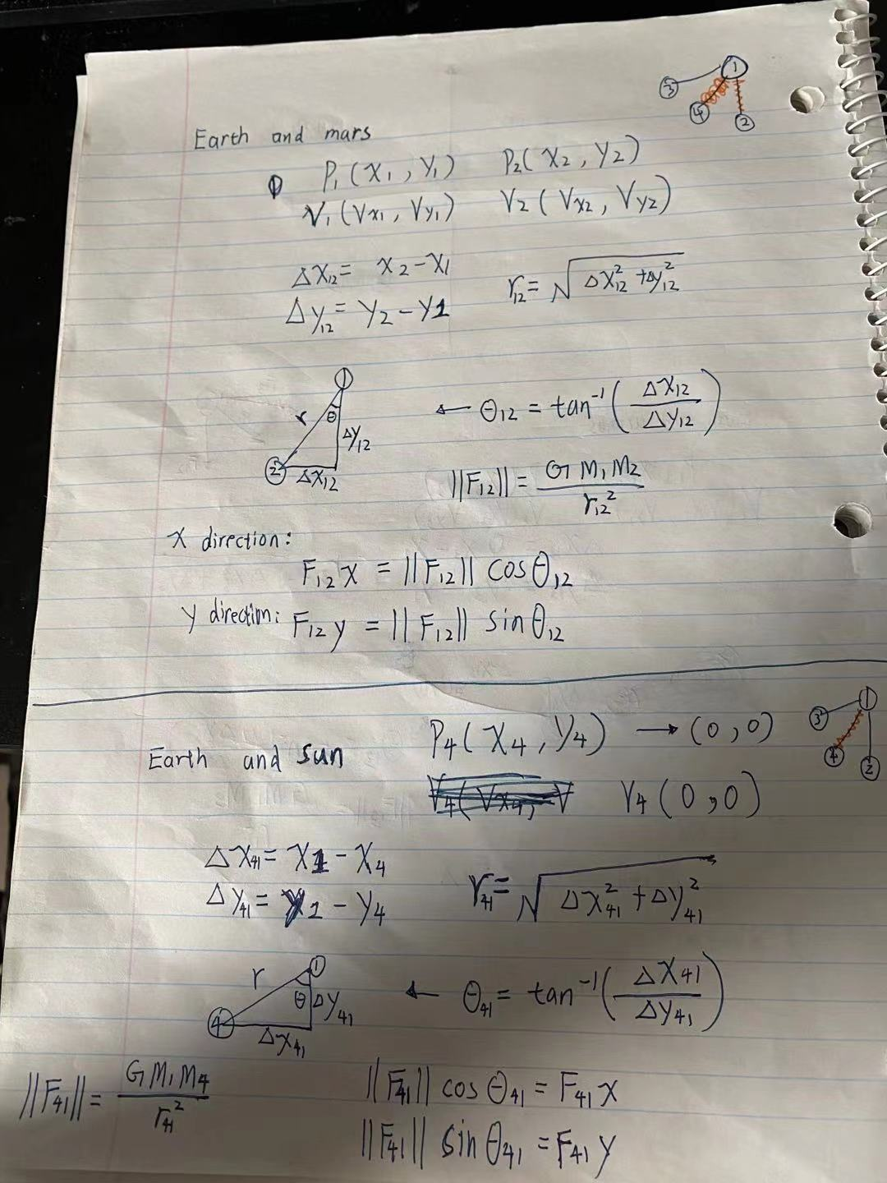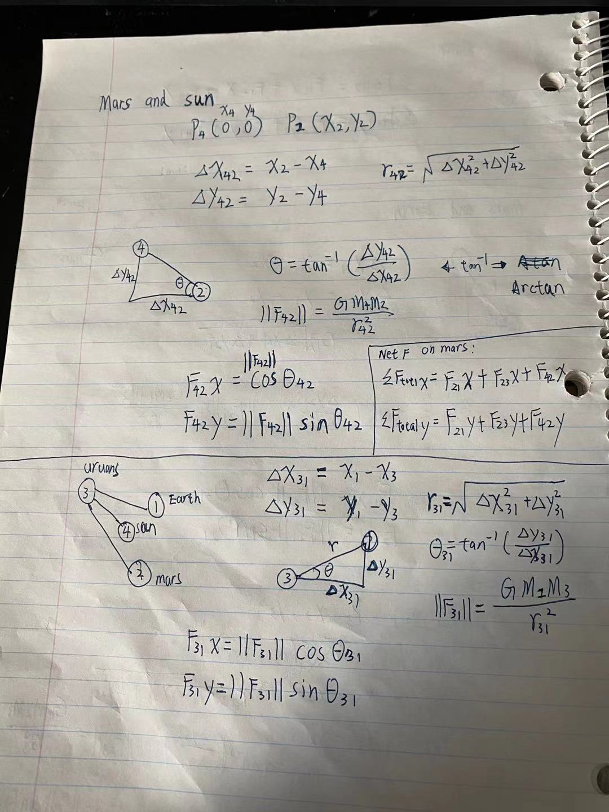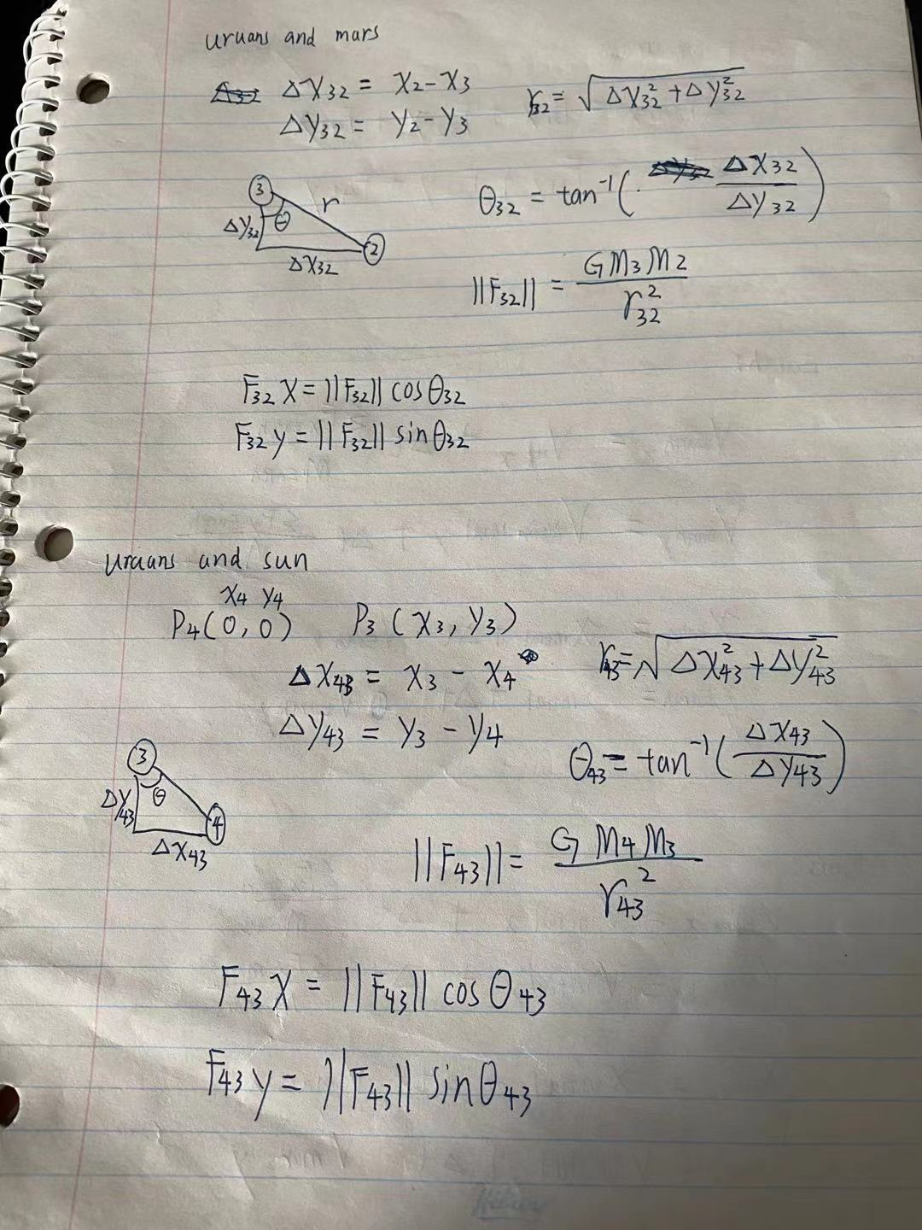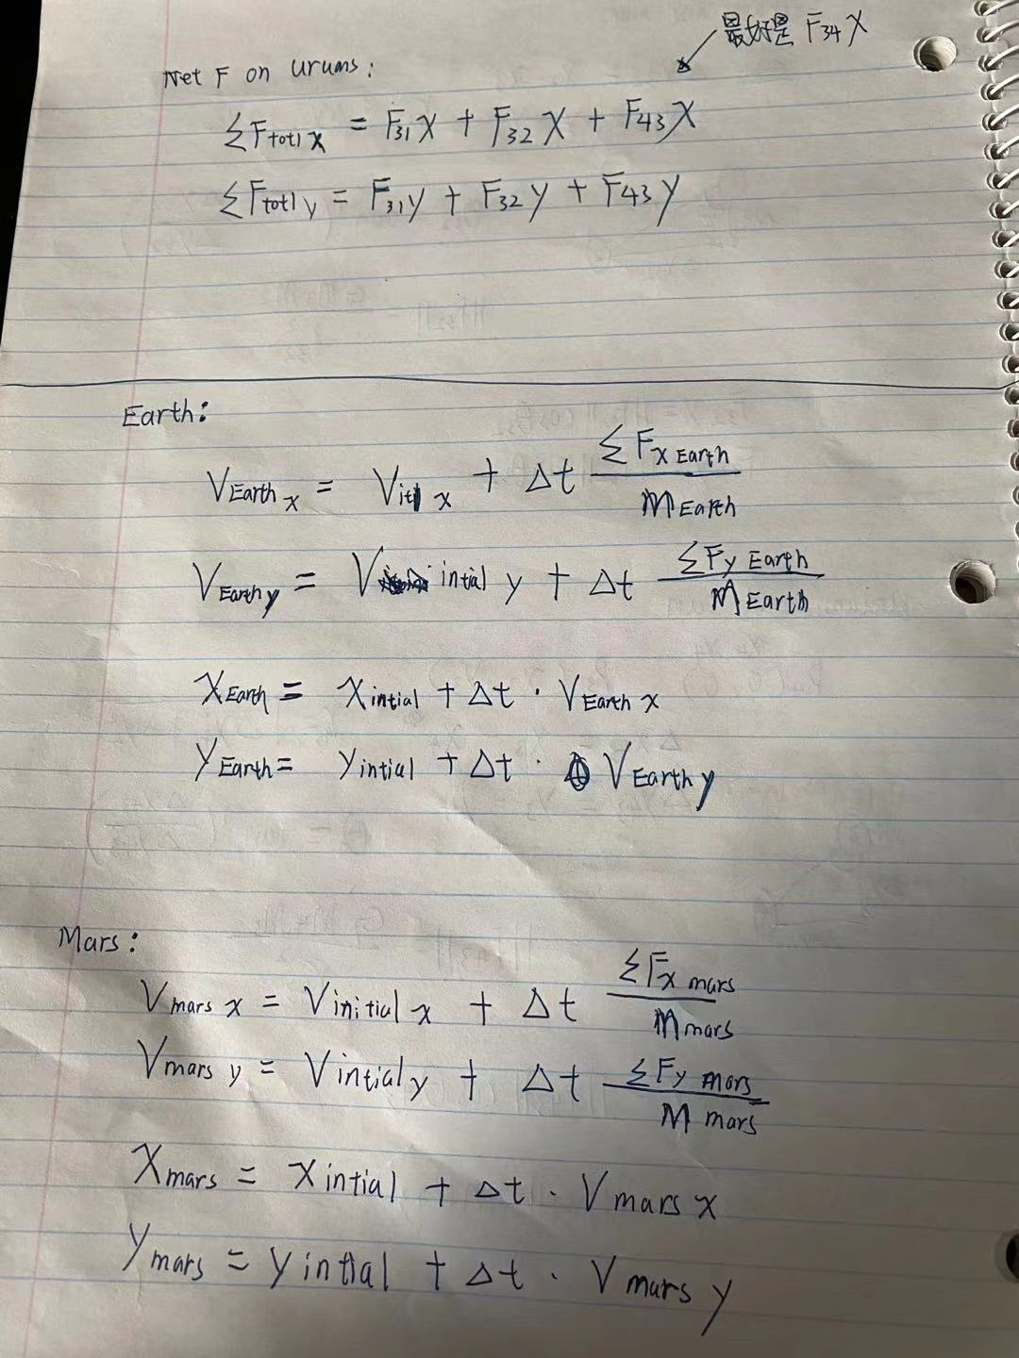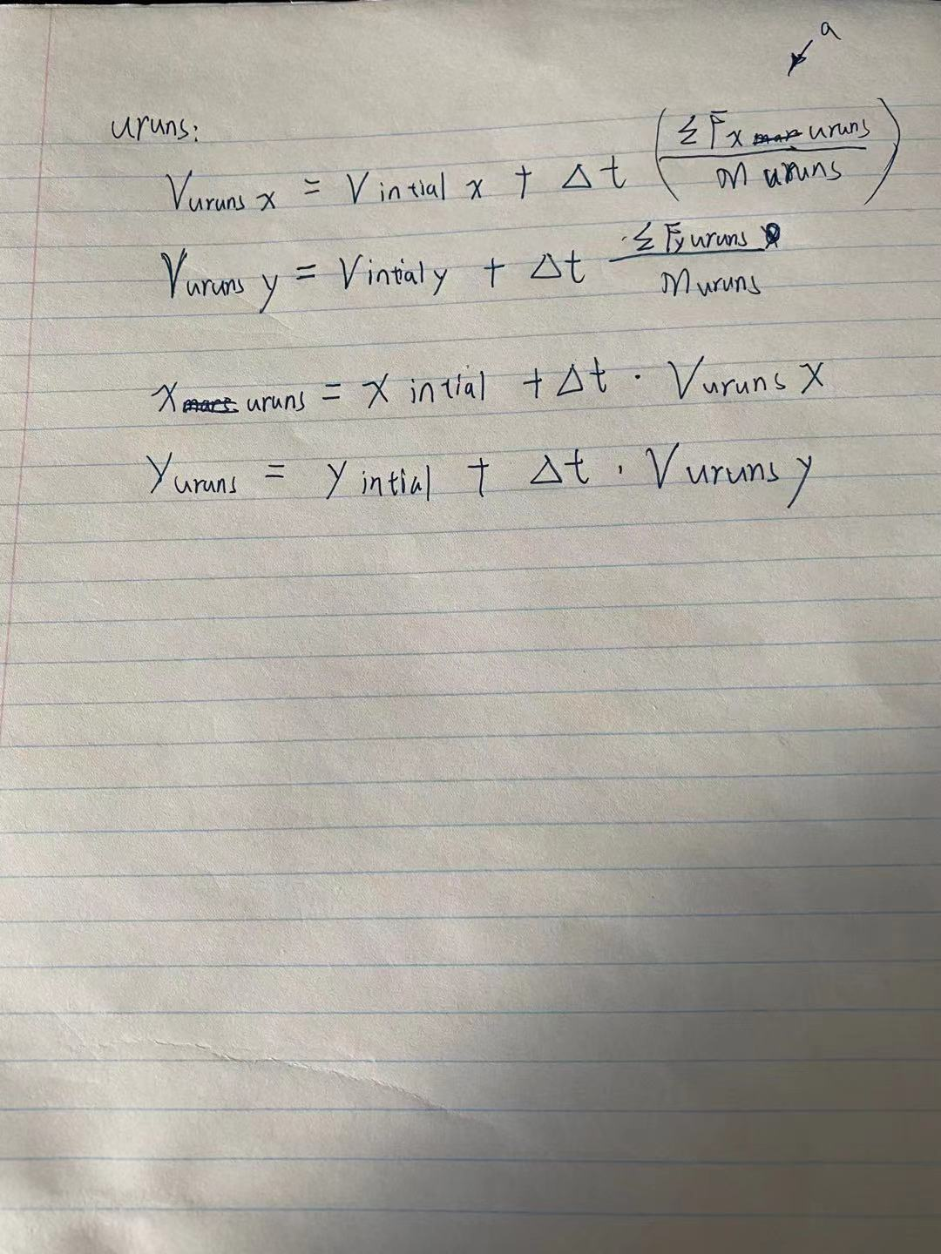

**All the initial values and the information of each planet are written at the top of the code. In the middle of the code, all the forces received by each planet and the speed and position at that moment. Finally, make a plot to show it.**

